**Power BI Assignment 3**

1. List and explain different PowerBi products?

Power Query.

Power Pivot.

Power View.

Power Map.

Power Q&A.

Power BI Desktop.

Power BI Website.

Power BI Mobile Apps.

1. What limitations of Excel, Microsoft solved by PowerBi?

* Excel has limitations in the amount of data it can work with. In contrast, Power BI can handle much larger amounts of data.
* Power BI can connect to a large number of data sources, while Excel's connectivity capacity is limited. Also, unlike Excel, Power BI can be easily used from mobile devices.
* Excel is used to organize data, transform it and perform mathematical operations and calculations. On the other hand, Power BI was conceived as a business intelligence and [data visualization](https://blog.bismart.com/en/data-visualization-with-power-bi) tool for businesses.
* Power BI has faster processing than Excel.
* Power BI dashboards are [more visually appealing, interactive and customizable](https://blog.bismart.com/en/reporting-services-and-highly-visual-and-interactive-reports) than those in Excel.
* Power BI is a more powerful tool than Excel in terms of comparison between tables, reports or data files.
* Power BI is more user friendly and easy to use than Excel.

1. Explain PowerQuery?

Power Query is **the data connectivity and data preparation technology that enables end users to seamlessly import and reshape data from within a wide range of Microsoft products**, including Excel, Power BI, Analysis Services, Dataverse, and more.

As the name suggests, Power Query is the most powerful data automation tool found in Excel 2010 and later. Power Query allows a user to import data into Excel through external sources, such as Text files, CSV files, Web, or Excel workbooks, to list a few. The data can then be cleaned and prepared for our requirements

1. Explain PowerMap?

Maps represent the location of any place, which uses coordinates or latitudes and longitudes to display a place on a map. In Power BI, it is integrated with bing maps. Bing is a search engine like Google to help users create maps.

1. How powerBi eliminated the need to host SharePoint Server on premises?

**Adding support for all major report types across both platforms**.

In the coming weeks, we’ll have the first public preview of Paginated (RDL) reports in Power BI Premium, giving customers full support for Paginated Reports, Power BI Reports and Excel Workbooks in Power BI.

· **Providing easier ways to report on your data in SharePoint.**

We’ve [recently announced new functionality](https://techcommunity.microsoft.com/t5/SharePoint-BI/New-feature-Create-Power-BI-reports-from-tables-in-Excel-files/td-p/201843) to make easier than ever to start visualizing your Excel tables and CSV files stored in SharePoint Online in Power BI.

Additionally, for Power BI Report Server, we’re adding some new features that already exist in Power BI, but were previously available only through SharePoint integration for on-premises deployments. These include –

· **Power Pivot Scheduled Data Refresh.**

We first added support for Excel Workbooks in Power BI Report Server in October 2017, including the hosting and viewing of Excel Workbooks containing data models. We’ll be expanding this support to include scheduled data refresh of these workbooks.

· **Modern Authentication support.**

Security considerations are a key part of any BI deployment strategy, and many customers used SharePoint to handle [claims-based authentication scenarios](https://docs.microsoft.com/en-us/sharepoint/dev/general-development/claims-based-identity-in-sharepoint) for their users. We’re adding native support for ADFS/AAD authentication to Power BI Report Server in an upcoming release.

1. Explain the updates done in Power Bi Service(power BI 2.0) as compared to older version ?

**Old workspace:**

There is a group of developers, and all of them has Edit access on the workspace. With the edit access in the old version of workspace, they can also publish and update the app. Now, while those developers are testing some new reports, and while users are using the app version of the workspace, if a developer suddenly by mistake click on update app, users will be impacted immediately! In the old version of workspace, a user who can publish and add content can also publish or update the app. There was no role for someone to take care ofupdating app only.

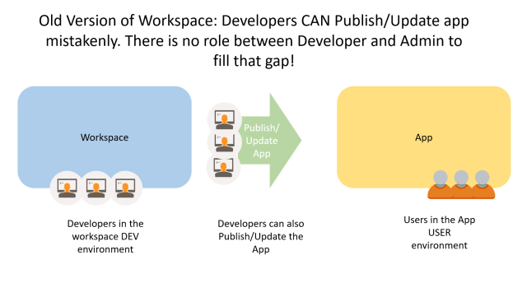

**New workspace:**

There is a group of developers and all of them have Contributor role. they can publish their content, test it in the workspace, they can update and change the content as they want. However, they cannot publish or update the app. For publishing or updating app, they have to ask a Member role to do that. This way, the environment setup is much more reliable than what you have read in the previous paragraph with the old version of the workspace.

